UNIT 6: MARVELLOUS MACHINES
Good morning, students!
I've written down the solutions to the activities you did yesterday. Correct them and then, we will continue to review the unit.
SOLUTIONS PAG 116
Exercise 1
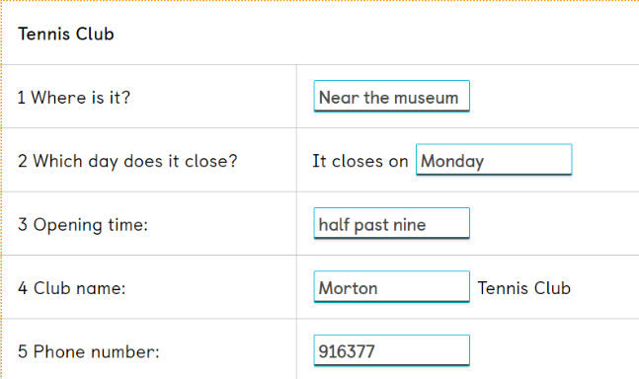
Exercise 2
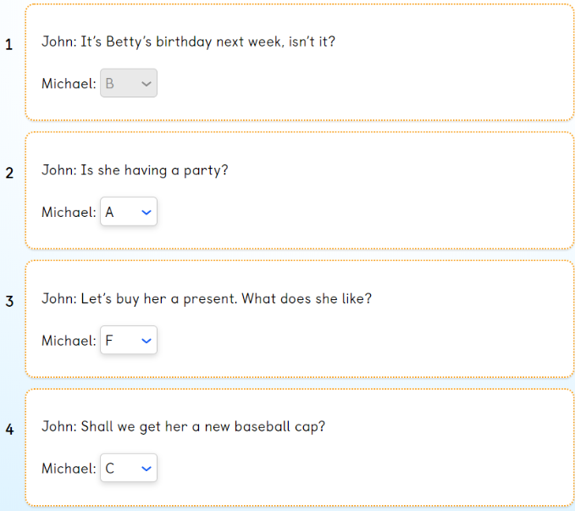
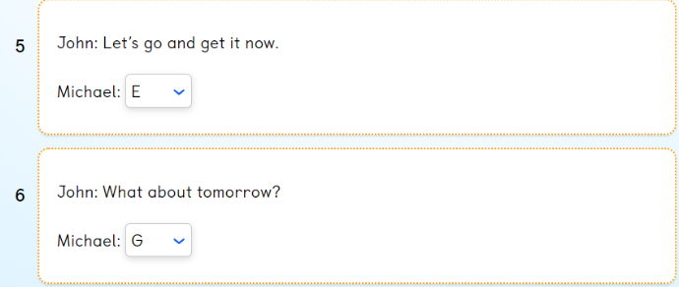
Exercise 3
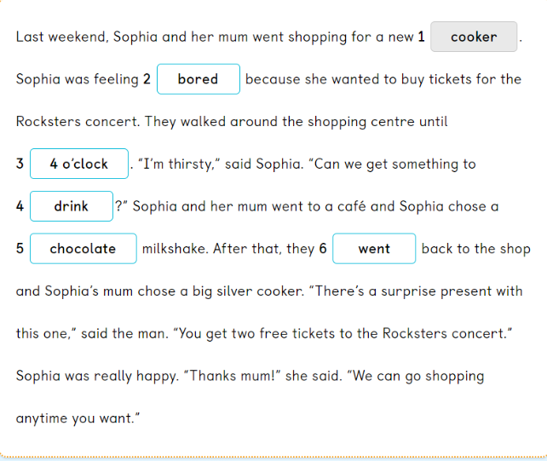
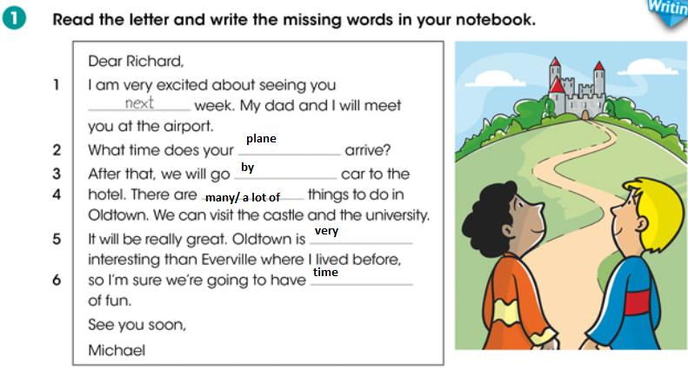
REVIEW: GRAMMAR AND VOCABULARY
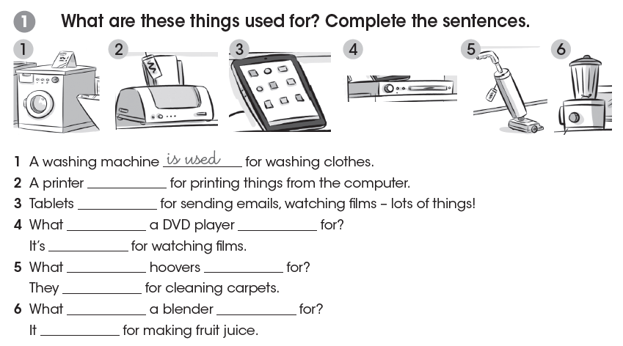
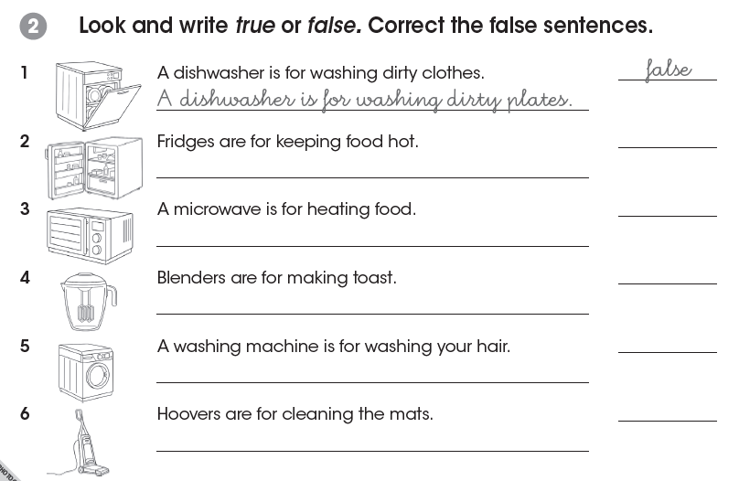
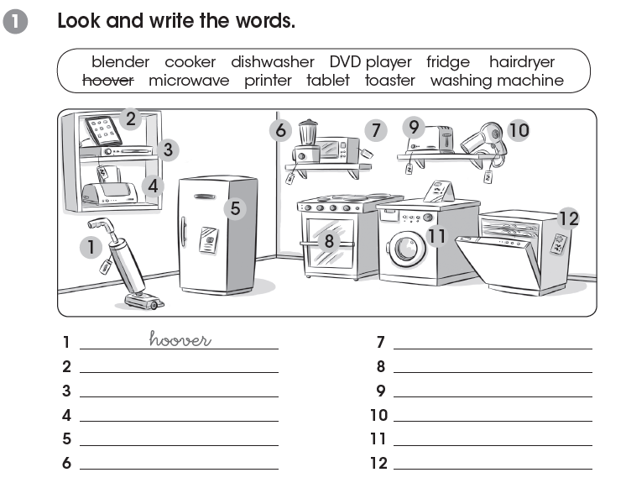
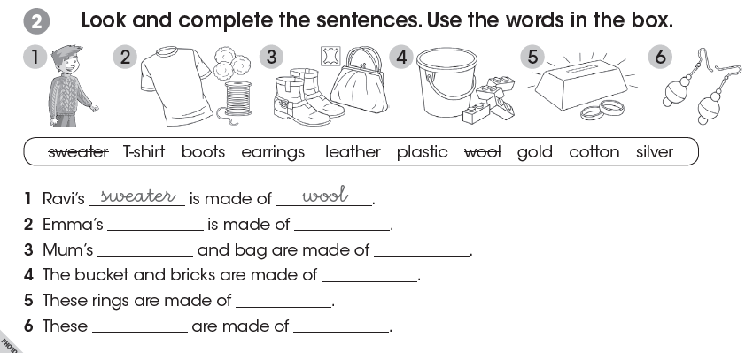
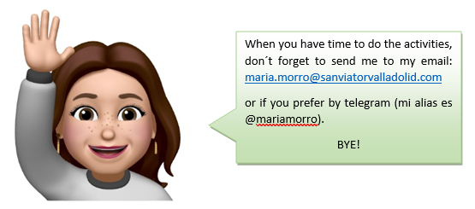
Cualquier duda que tengáis no dudéis en contactar conmigo. Recuerda que mañana haremos una prueba para finalizar la unidad 6.

