UNIT 6: MARVELLOUS MACHINES
Good morning, students!
I have written the solutions of the exercises you did on Wednesday for you correct them. Then, we continue with the unit.
SOLUTIONS PAG: 61
Exercise 1
- Gold, letter e
- Silver, letter c
- Are made of leather, letter d
- Is made of cotton, letter b
- Is made of plastic, letter f
- Is made of wool, letter a
Exercise 2
- Boots are made of leather
- A sweater is made of wool
- Earrings are made of gold
- A t-shirt is made of cotton
Exercise 3 (respuesta abierta, os pongo varios ejemplos)
- I´m wearing glasses. They´re made of metal
- I´m wearing socks. They´re made of cotton
Exercise 4: Listening
- It´s small, it´s made of silver. It´s used for decorating your neck. It´s a necklace (TRUE).
- It´s small, it´s made of wool. It´s used for keeping your head warm. They´re gloves. (False, it´s a hat)
- It´s big, it´s made of leather. It´s used for carrying things. It´s a chair. (False, It´s a suitcase)
- It´s big, it´s made of plastic. It´s used for drying your hair. It´s a hairdryer. (True)
- It´s small, it´s made of silver. I´s used for decorating your ears. They´re earrings. (True)
CODE ACTIVITY: MAKE A CAKE

ACTIVITIES

- Do exercise 1 on page 62.
Vocabulary: nose, snowman (muñeco de nieve), goat (cabra), coat, robot, phone, roll, boat, bone (hueso), rainbow (arco iris), window.
Os dejo además un video para que veáis como es la pronunciación: https://www.youtube.com/watch?v=NZHn2UhrLZM

- Reading: Lee el siguiente anuncio
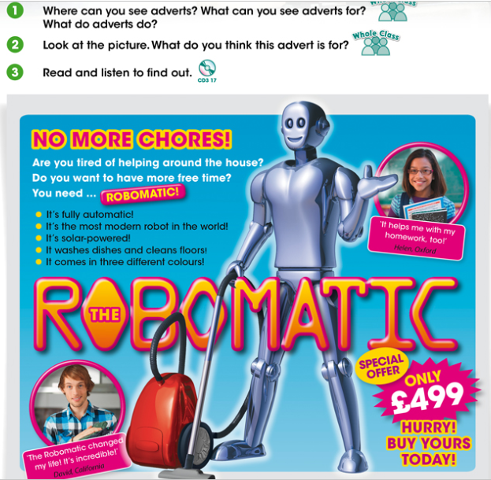
Vocabulary:
  - Chores = tareas
  - Advert = anuncio, propaganda.
- Do exercise 1, 2 and 3 on page 63

Para aquellos que no tienen el libro, dejo a continuación los enunciados de los ejercicios:
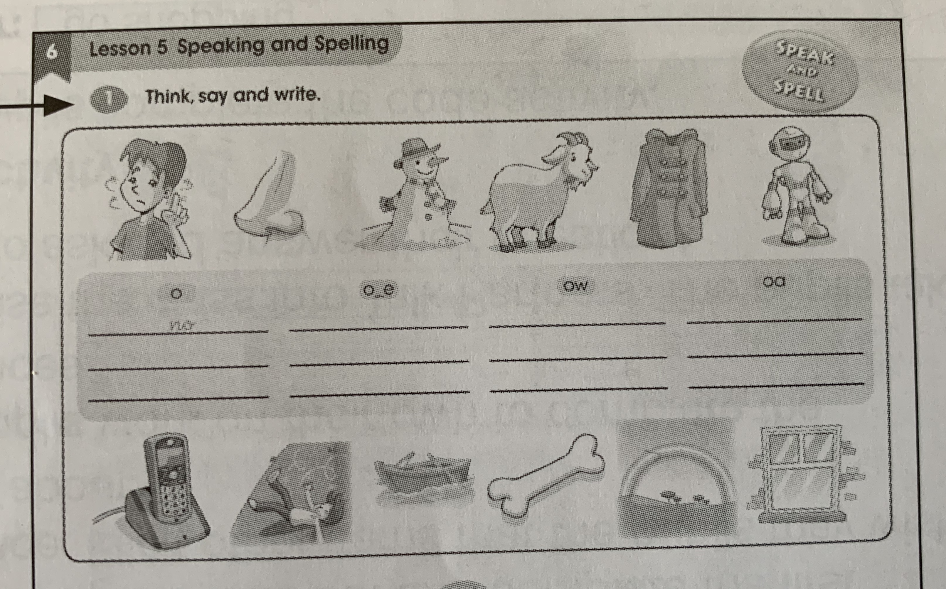

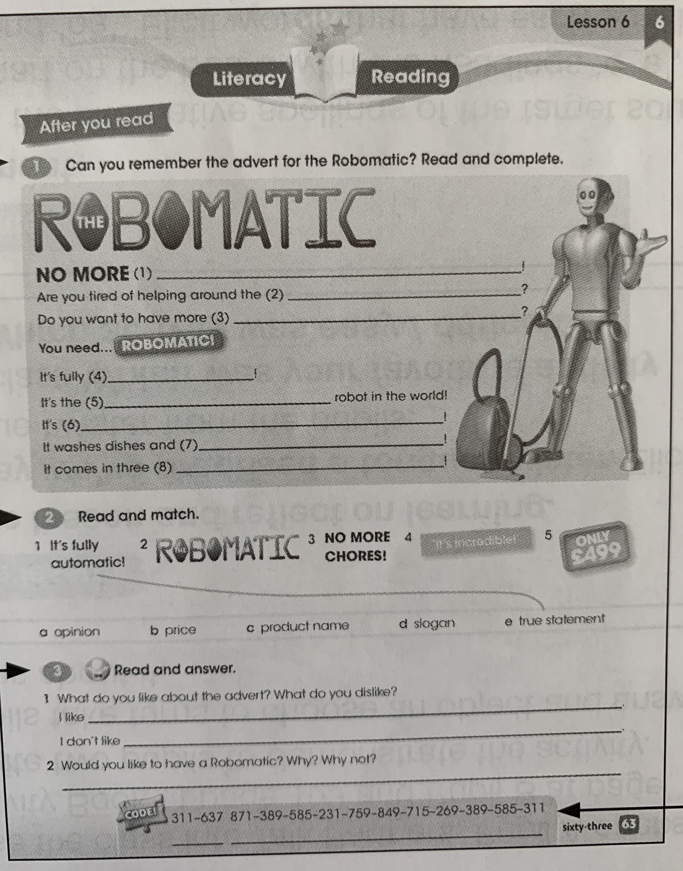
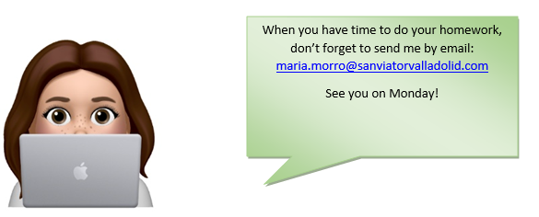
Editorial: Macmillan

