UNIT 5: LET´S HAVE FUN!
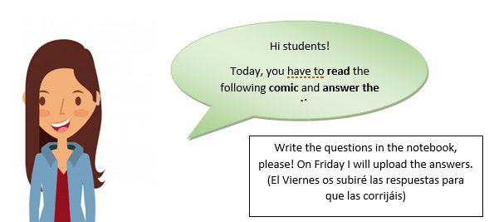
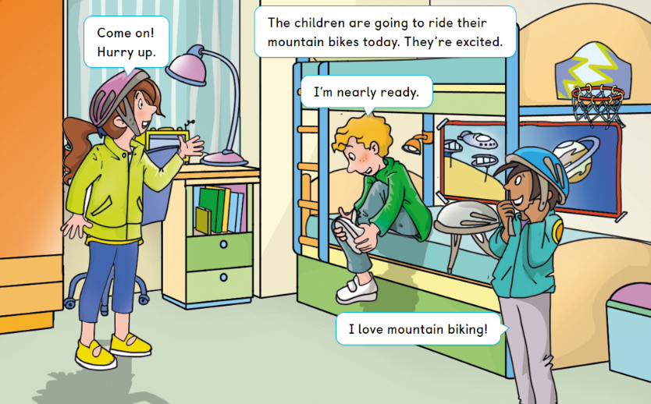
Vocabulary:
- Hurry up = Darse prisa
- Excited = emocionado
- Question: what are they going to do today?
_______________________________________________________________________
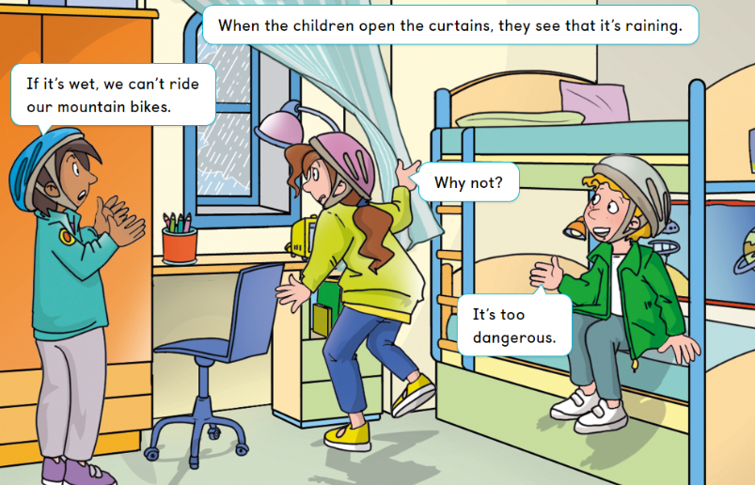
Vocabulary: wet = mojado
Question: Why can´t they ride their mountain bikes?
_____________________________________________________________________________
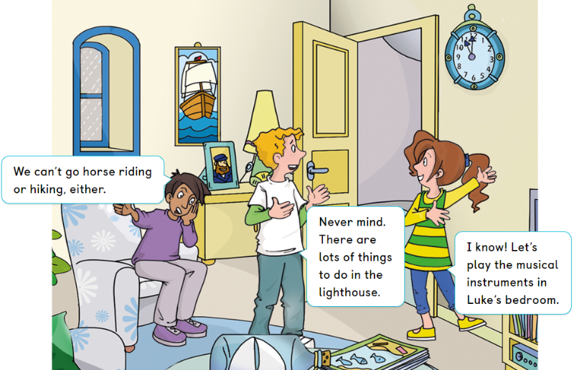
Vocabulary:
- Never mind = No importa
- Lighthouse = faro
Question: Indicates True or False : (señala si es verdadero o falso)
- The decide to go hiking _____
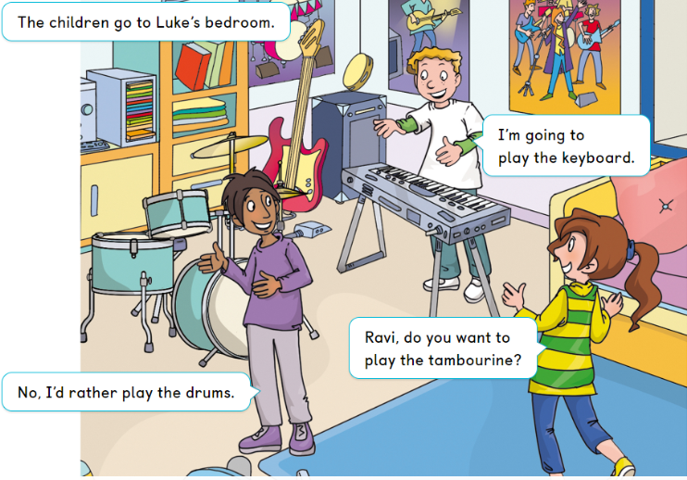
Question: Indicates True or False:
- Ravi would rather play the tambourine ___
(recuerda que rather significa preferiría)
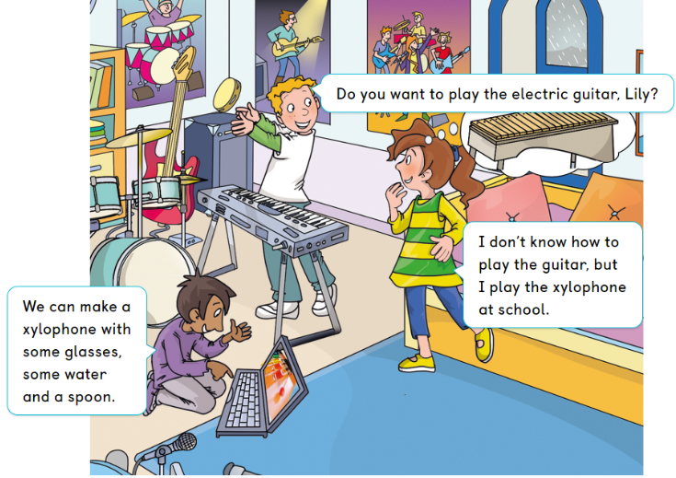
Vocabulary: spoon = cuchara
Question: What musical instrument does Lily play at school?
_____________________________________________________________________________

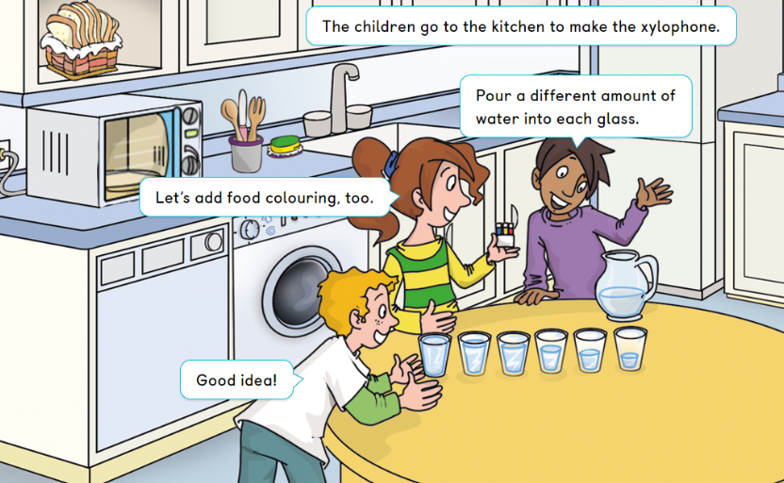
Vocabulary = amount of = cantidad de
Question: Indicates True or False
- The children put the same amount of water into each glass ___
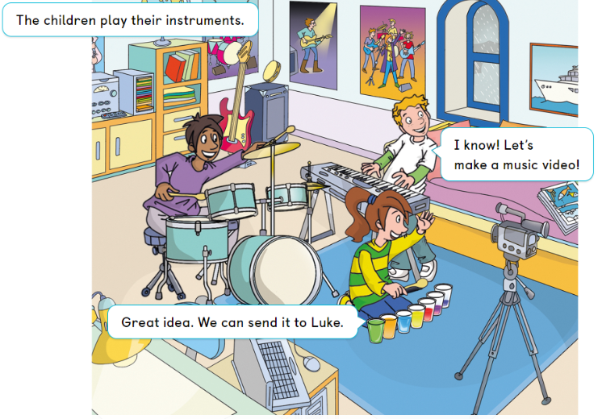
Question: What do the children decide to do?
_____________________________________________________________________________
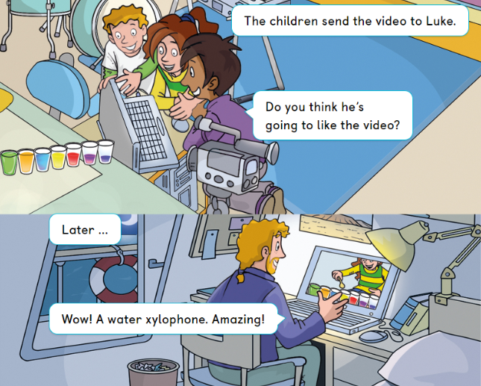
Question: Does Luke like their video?
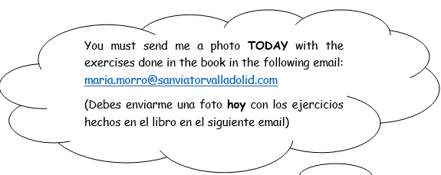
Wedneday, 18th March 2020

Para resolver dudas puedes contactar conmigo en el siguiente email: maria.morro@sanviatorvalladolid.com

