Monday 8th June:
Hello children’s:
The activities to the Activity BooK, you must complete in the activity book.
The grammar you must copy in your note book, take a photo and send me.
And the activities that I send you to review, complete on the computer.
If you can’t hear the audios, tell me and I will send it to your email as an attachment, please.(Si no podéis escuchar los audios por favor decírmelo y os lo mando a vuestro correo como archivo adjunto).

Nº 1.
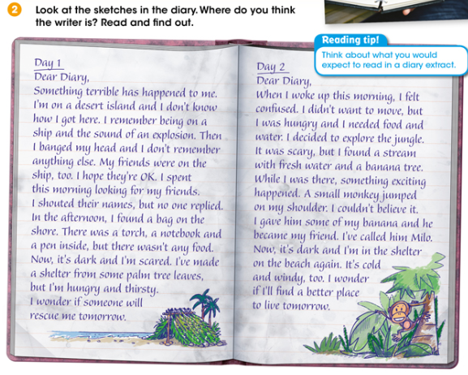
Answer:

Activity BooK:
Page 85: Nº1. Read and order.
Page 85: Nº2. Read and answer the questions.
Page 85: Nº3. Listen and circle A, B or C.
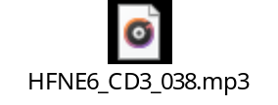
Page 85: Nº 4. Answer the question.

Nº 2. Read the diary.
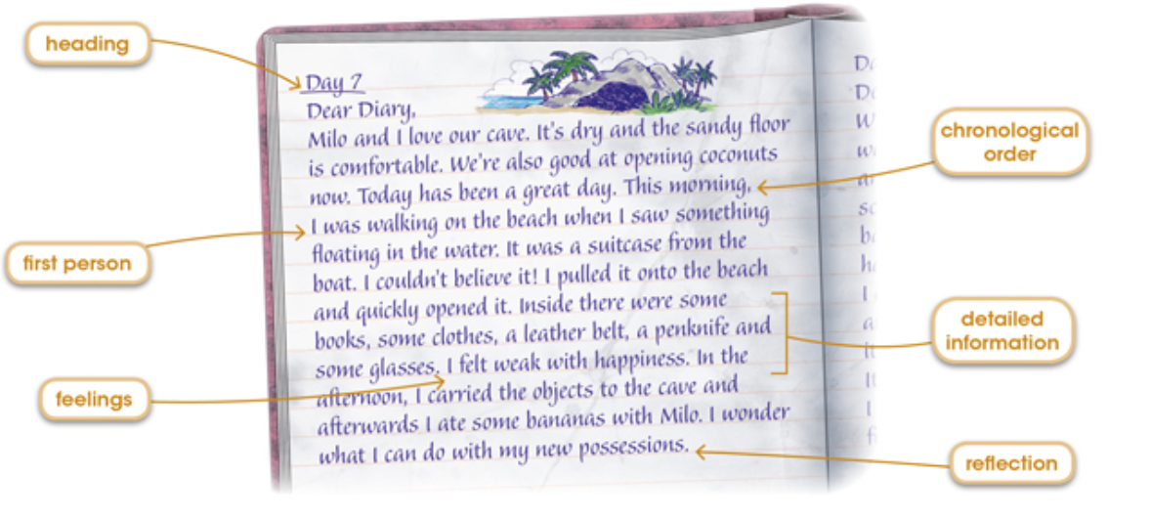

Nº 3. Copy the personal pronouns and possessive adjectives in your note book. Take a photo and send me.

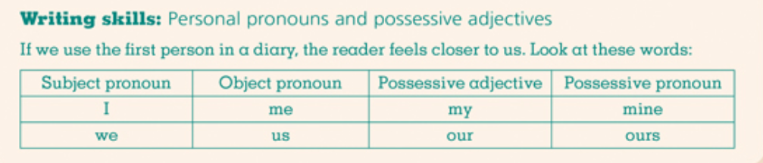

Activity BooK:
Page 86: Nº1. Complete the sentences.
Page 86: Nº2. Plan your writing.
Page 86: Nº3. Write your diary in your note book. Use your notes in Activity 2. Take a photo and send me.

“Una vez hechas las tareas y los ejercicios y para dudas, puedes contactar conmigo en el siguiente e-mail”:
veronica.tauler@sanviatorvalladolid.com

