Good morning, students!
Today we're going to read Luke's new adventure!

READ AND ANSWER
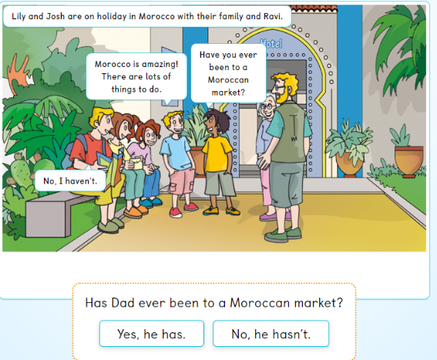
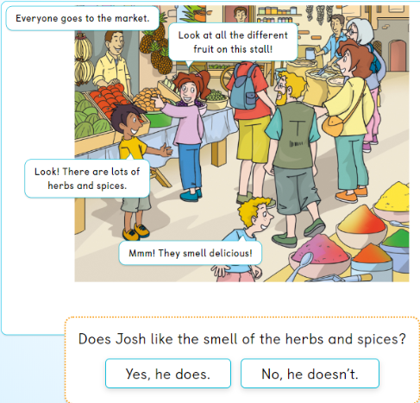
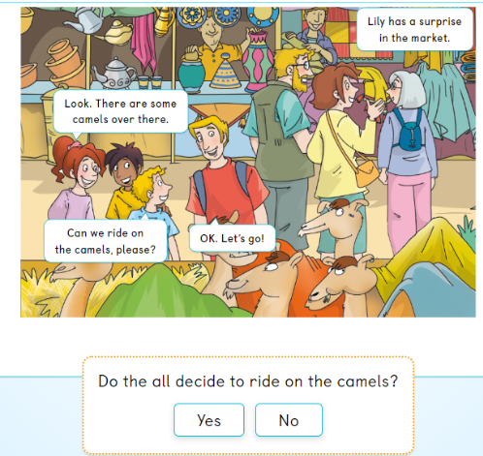
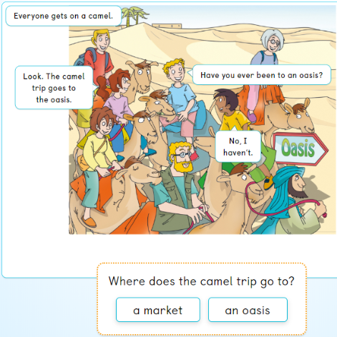
Vocabulary:
The camel trip: el viaje a camello
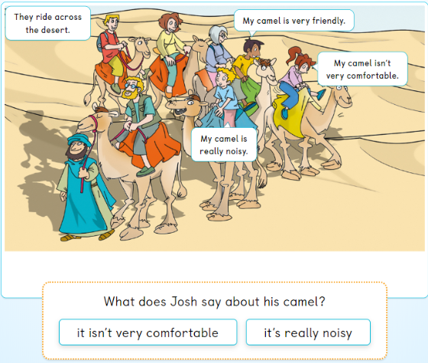
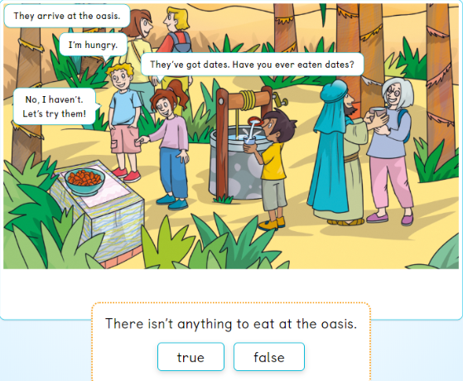
Vocabulary:
Let´s try them! = ¡Vamos a probarlos!
Dates: dátiles
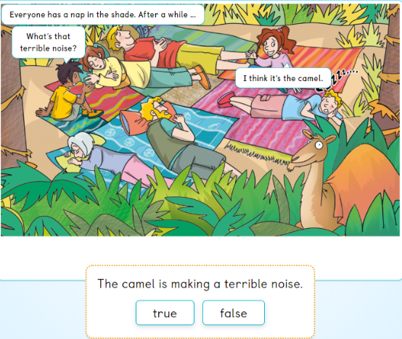
Vocabulary:
Nap = siesta
Shade = sombra
After a while… = después de un tiempo…
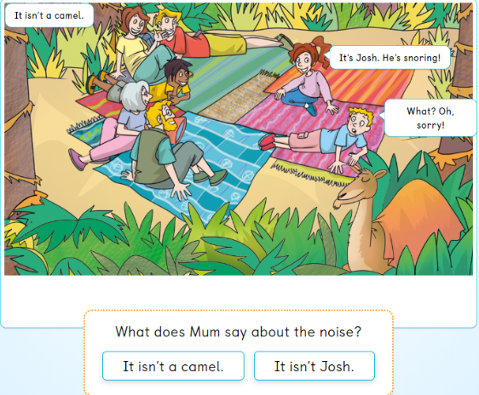
Vocabulary:
He´s snoring! = ¡Él está roncando!

When you have time to do your homework don´t forget to send it to my email: maria.morro@sanviatorvalladolid.com , or if you prefer by telegram, @mariamorro.

