Wednesday 3rd June:
Hello children’s:
The activities to the Activity BooK, you must complete in the activity book.
The grammar you must copy in your note book, take a photo and send me.
And the activities that I send you to review, complete on the computer.
If you can’t hear the audios, tell me and I will send it to your email as an attachment, please.(Si no podéis escuchar los audios por favor decírmelo y os lo mando a vuestro correo como archivo adjunto).

Nº 1. Read and listen.
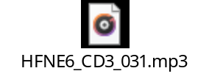
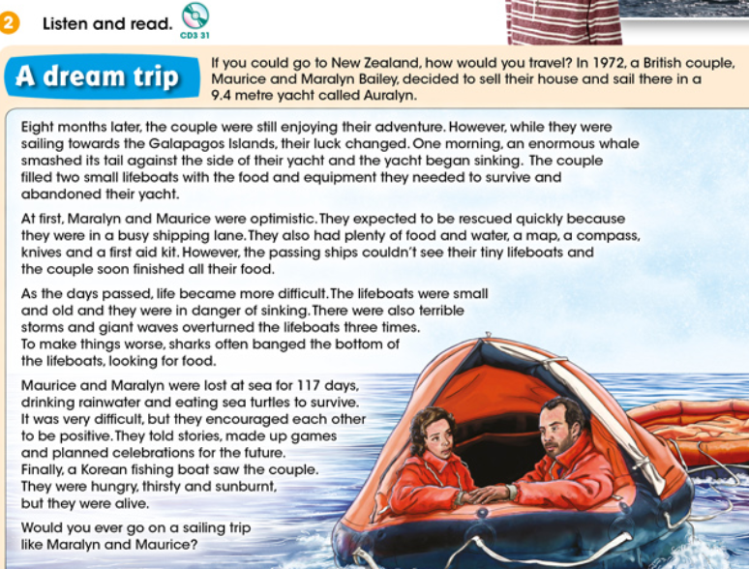

Activity BooK:

Page 82: Nº1. Remember the story and answer.
Page 82: Nº2. Listen and complete.
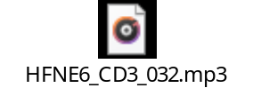
Page 82: Nº3. What do you think?
Page 82: Nº4. Find out about Ecuador.

Nº 2. Listen and read.
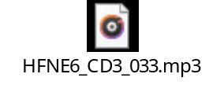
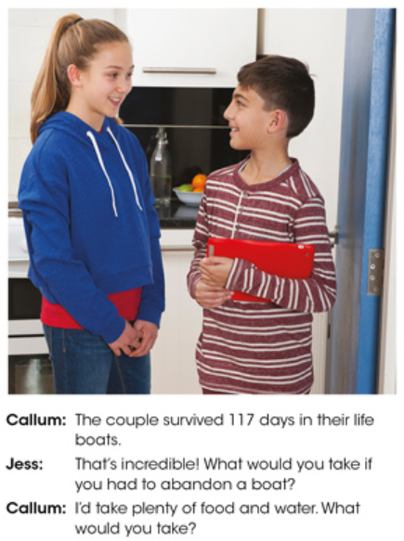
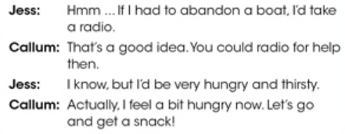
Nº 3. Look, copy grammar wall in your note book and learn. Take a photo and send me.
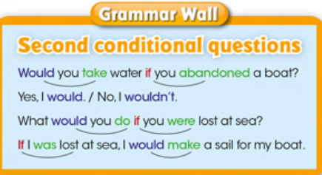

Nº 4. Think and choose.

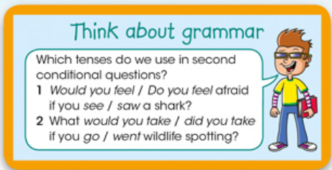
Answers:

Nº 5. Write sentences with the second conditional questions and second conditional, using this vocabulary. Look at the examples.
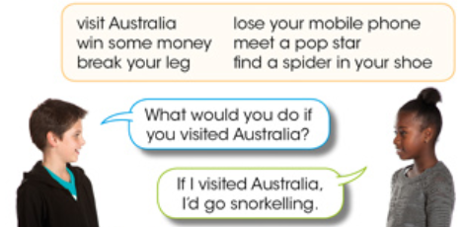

Sentences:

“Una vez hechas las tareas y los ejercicios y para dudas, puedes contactar conmigo en el siguiente e-mail”:
veronica.tauler@sanviatorvalladolid.com

