Wednesday 20th May:
Hello children’s, good morning:
The activities to the Activity BooK, you must complete in the book.
The grammar you must copy in your note book, take a photo and send me.
And the activities that I send you to review, complete on the computer.
If you can’t hear the audios, tell me and I will send it to your email as an attachment, please.(Si no podéis escuchar los audios por favor decírmelo y os lo mando a vuestro correo como archivo adjunto).

Nº 1. 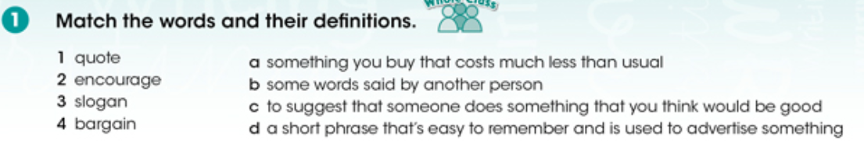
Answers:

Nº 2.
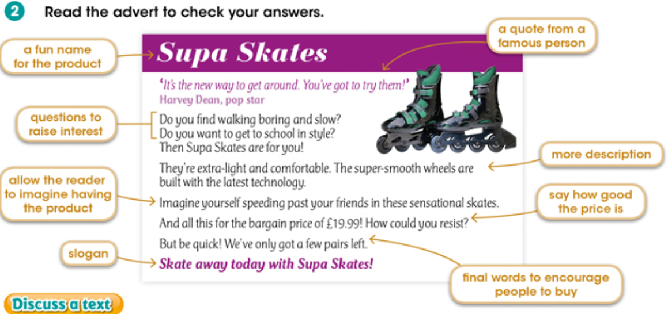

Nº 3.
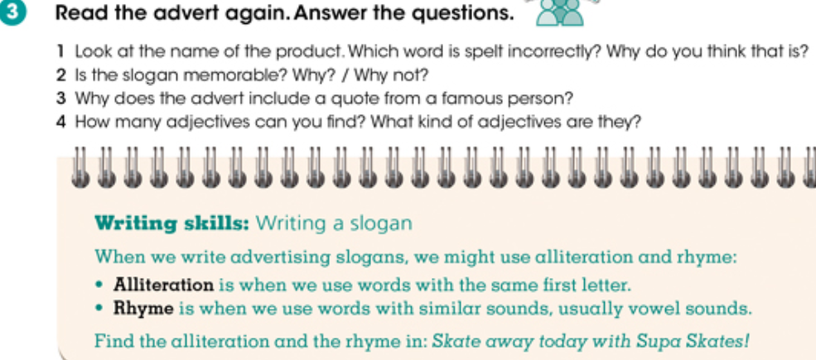

Answers:

Nº 4. Activity BooK:

Page 76: Nº 1. Write slogans for these products.
Page 76: Nº 2. Plan your advert.
Page 76: Nº 3. Write your advert in tour note book. Use the notes that write in nº 2.
.

“Una vez hechas las tareas y los ejercicios y para dudas, puedes contactar conmigo en el siguiente e-mail”:
veronica.tauler@sanviatorvalladolid.com

