TAREA 3 SEMANA 14 AL 17 DE ABRIL
Good morning!
Today, we are going to work with symmetry. Do you remember what is symmetry? Symmetry is when an object looks the exact same on one side as the other.
For example:
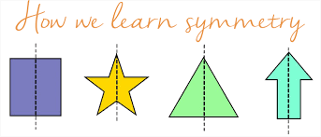

This is the axis
So, today we are going to work with symmetry. You have to create a form (with lines, dots…) in a kitchen paper. I will show you examples, but you can create whatever you want.
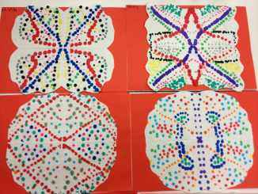

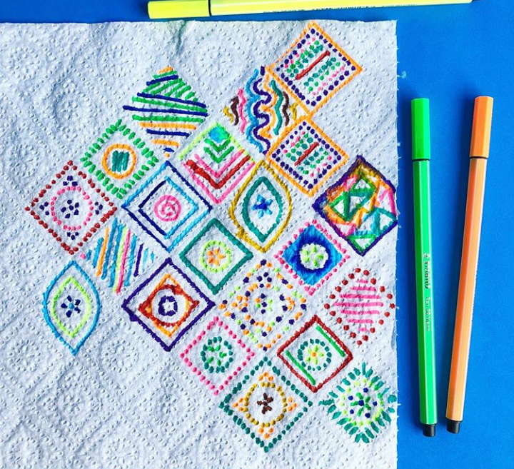

Materials that you will need:
- Kitchen paper.
- Felt-tips pens.
- Your imagination.

Explicación:
Tenéis que trabajar la simetría. Tendréis que crear una forma, un animal….lo que queráis en papel de cocina utilizando rotuladores de colores (como veis en el ejemplo que os he puesto).
¡Ánimo, quiero ver vuestra creatividad e imaginación!

Remember to send me the homework to my email (RECUERDA ENVIARME LOS DEBERES A MI EMAIL)
luisa.fernandez@sanviatorvalladolid.com
If you have any question just tell me and I will be glad to help you

