UNIT 5: LET´S HAVE FUN!
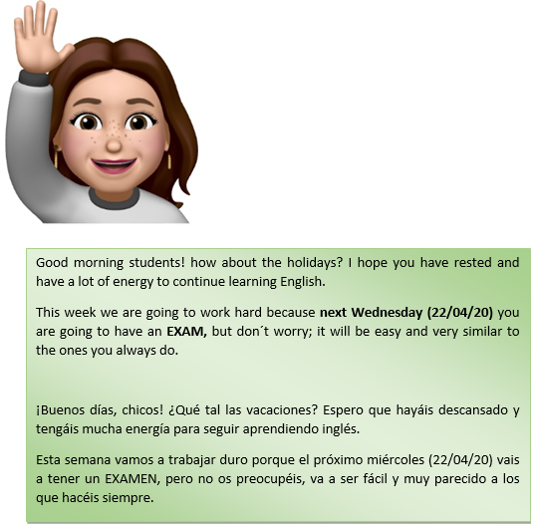
The first thing of all I am going to write the solutions of the last activity you did:
Luke´s Questions:
- What are bagpipes made from?
The bagpipes are made from wood
- Which instrument comes from Trinidad and Tobago?
The steel drum

- What´s a didgeridoo made from?
It´s made from the trunk or branch of a tree.
- What´s the sitar like?
It looks like a guitar
- What is probably the oldest instrument in the world?
The Didgeridoo.
- How many strings does the sitar have?
It´s got about 20 strings.
- Do you play an instrument? If you don´t play any instrument which one would you like to know how to play? (respuesta abierta)
- Yes, I play the……….
- No, I don’t play any instrument but I would like to play the……

HOMEWORK
- Today, you have to do the exercises (1,2,3) on page 50. The second exercise I will put a video with the audio so that you can correct the mistakes.
Audio: https://youtu.be/LMG-l1z3YlA
- You must also do the exercises (1,2,3) on page 55. In the first exercise, I also put the audio link, and in the second exercise, you have to look for information about New Zeland.
Audio: https://youtu.be/thj29u4qz9o
- In addition, I am going to put you a song on page 52 to listen to you, I also leave you the letter of the song. (para que escucheis la pronunciación)
Song: https://youtu.be/Teyk4A14Slc
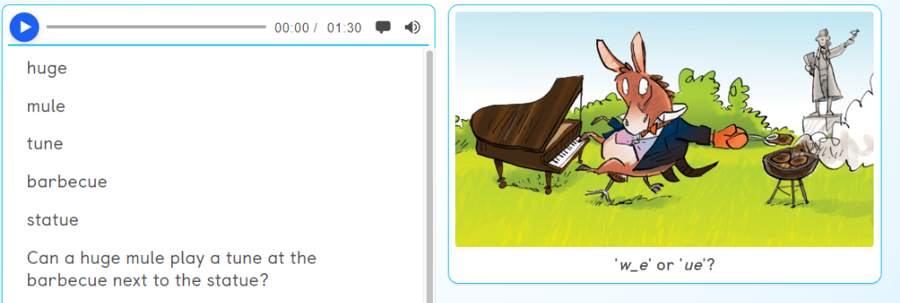

Si alguno tiene problemas para escuchar los audios, contacta conmigo en el siguiente email: maria.morro@sanviatorvalladolid.com

Para aquellos que no tienen el libro de inglés estas son las actividades que hay que hacer:

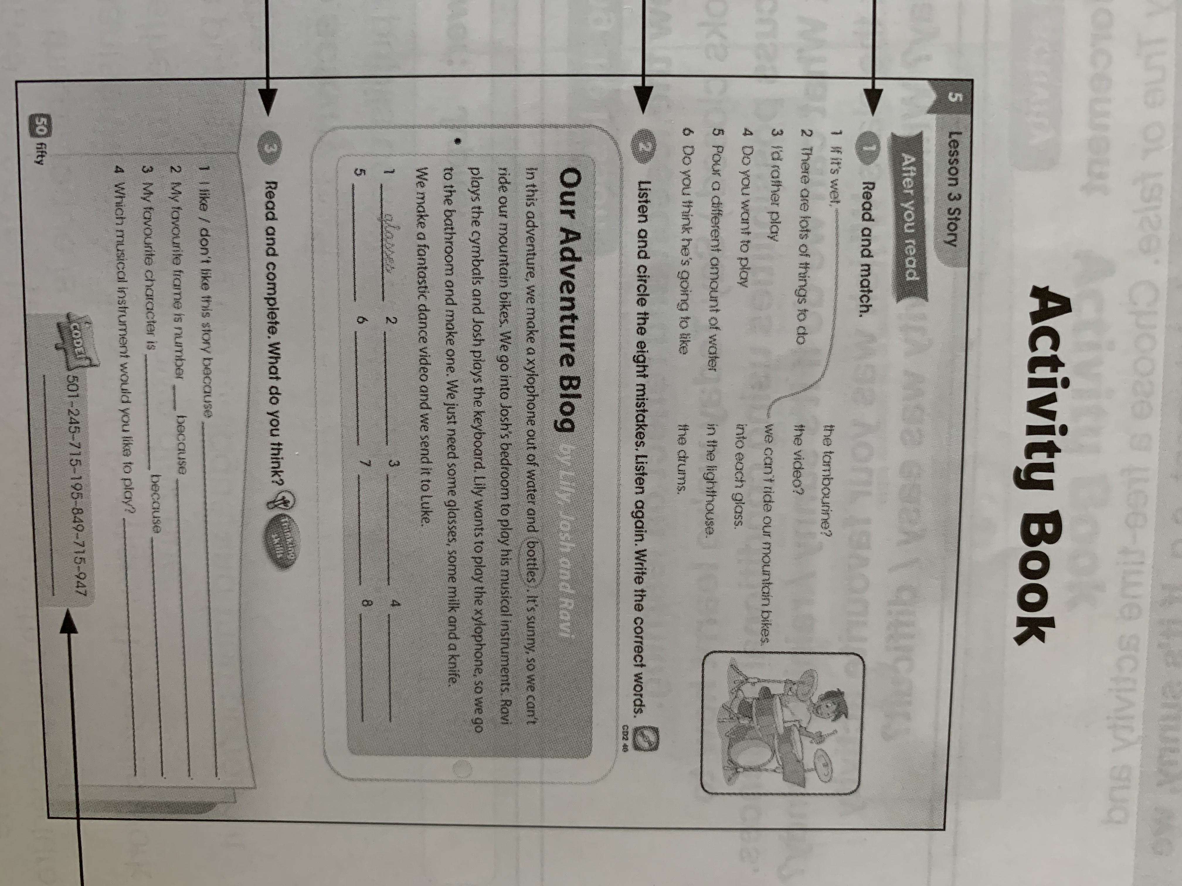
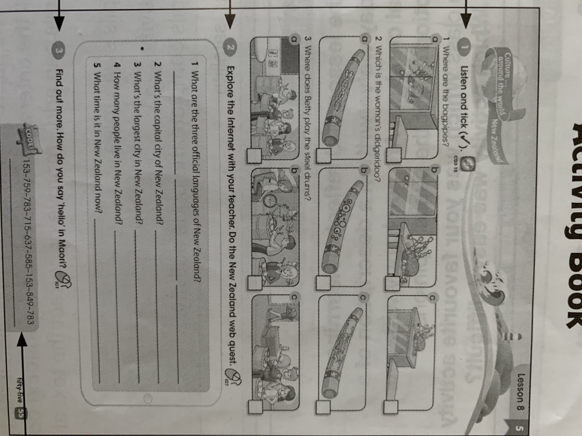

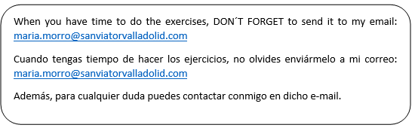
Tuesday, 14 th April 2020

