STRUCTURES (1)
- STRUCTURES
All physical bodies or objects have a structure. Its purpose is to maintain the object’s shape and not to break when a force acts on them. An elephant’s skeleton or the grooves1 on a plastic cup are examples of structures.
A structure is the set of elements in a body that are made to resist the effects of the forces that act on it. A structure prevents a body from breaking or deforming.
- FORCES ANDO LOADS
Physical bodies and objects need a structure to support the different forces that act on6 them, like gravity which attracts objects to Earth and cause them to have weight.
A force is anything that can deform a body (static effect) or make it move or stop (dynamic effect).
There are two main types of loads:
Fixed or permanent loads are constant – they don’t vary over time. An example would be the weight of the structure of a bridge and its component parts (columns, road surface, etc.).
Variable loads vary over time, like the traffic going across a bridge or the wind hitting it.
A load is a force that acts on a structure. It can be fixed or variable.
- STRESS
If we pull one of our fingers, bend it backwards, or push our palms together, we can feel a tension that grows as we pull, bend or push harder.
We also notice that the feeling is different in each case because we have applied force in a different way each time.
Stress is the internal tension which all bodies experience when one or more forces are applied to them.
  - Types of stress
We classify stress by the deformation it produces: traction, compression, bending, torsion and shearing or cutting.
STRESS | DEFINITION AND CARACTERISTICS | REPRESENTATION | EXAMPLE
Traction | Traction is produced when forces try to stretch the body they act on.  These forces are opposing. That is, they go in the same direction but with different trajectories – away from each other. | 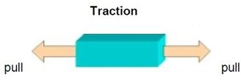 | The rubber band of a catapult  The cables on a suspension bridge  The chord on blinds.
Compression | We see this when forces try to crush or compress a body.  These forces are opposing, with the same trajectory – inwards on the object. | 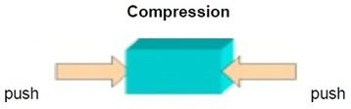 | The legs of a table  The columns of a bridge  A person’s legs while standing
Torsion | This is when forces try to bend9 the body they act on.  They are not opposing, in the same trajectory direction, but separate from each other. | 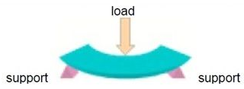 | The deck of a bridge between the supports  The bar in a wardrobe.
Shearing | In this case, the forces try to twist10 the body they act on.  The forces try to turn and they act in different directions. | 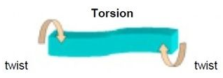 | When we sharpen a pencil or turn a key to open a door.
Cutting | When we apply this force, we are using forces that try to divide11 something. These forces act very near each other, but not opposing – one goes up and the other goes down. | 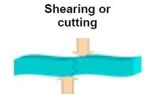 | When we cut a sheet of metal  When a picture hangs on a hook on the wall.

- MAN MADE STRUCTURES
TYPE | DEFINITION AND CARACTERISTICS | PICTURE | EXAMPLE
Masive structures and lintels | The first man-made structures were carved from rock or were built by stacking rocks or other materials. This left little space between them, like in the Mayan or Egyptian pyramids.  Short stone or wooden lintels were also used to make windows and open spaces. | 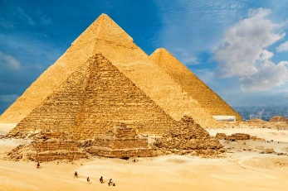 | Pyramid of Giza  Dams
Vaulted structures | With arches and vaults, builders could cover larger spaces and have bigger gaps in the structures.  Vaulted structures are formed by arches and vaults using stones that are cut in such a way that the only stress they support is compression – no problem for hard stone. | 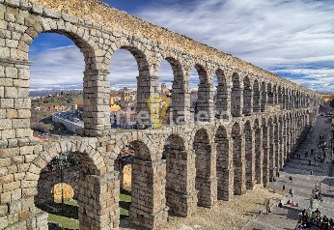 | Aqueduct of Segovia  Ribbed vaults and pointed arches.
Triangular structures | These structures are made from bars, normally metal or wooden. The use of triangular shapes means they are not easily deformed. This makes them ideal for building bridges (triangular beams), covered with large trusses and vertical structures, like towers and scaffolds. | 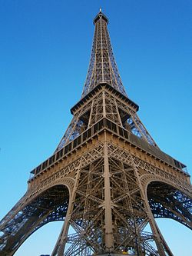 | Eiffel tower.  Railway bridges
Suspended structures | This type of structure uses cables, called suspenders which the structure hangs from. When they can be adjusted, they are called tension members.  The cables only bear traction stress, but the advantage is that they can adapt their shape to different loads at different times and they are incredibly light.  Cables are used to fasten bridges, marquees, antennas and towers. |  | Golden gate  Cable-stayed bridge
Reinforced concrete structures | Concrete led to major advances18 in construction because it could be made into any shape. Concrete resists compression and with steel rebar frameworks it can also bear traction.  It is a very strong material which is used in all types of building, mostly in framework structures like your school: | 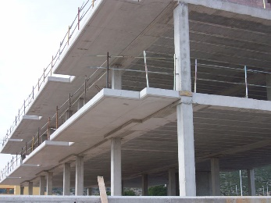 | Almost any kind of building and bridge.

PRACTICE
Now we are going to practice and create our own structure. For doing it, you need the following materials and tools.
Materials:
- 20 sheets of used paper. It could be newspaper sheets, magazine sheets, or any kind of paper that you have used before and you don’t need it anymore.
- Adhesive tape
Tools
- Scissors
Construction:
STEPS
You roll the sheets of paper around one corner. The paper should be very tight when rolling, in this way we will get stronger bars. | 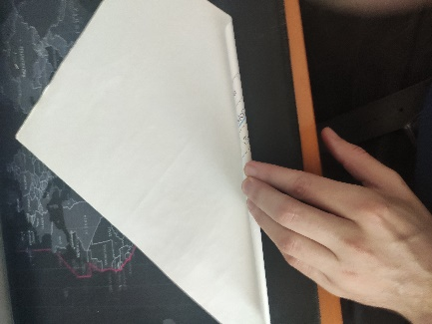
When you get close to the end, secure the corner with a piece of adhesive tape. | 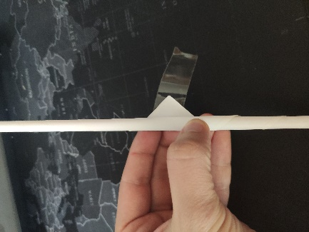
The final result will be something like that. | 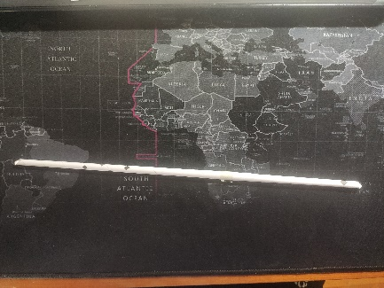
You have to repeat this, until you have 16 bars. | 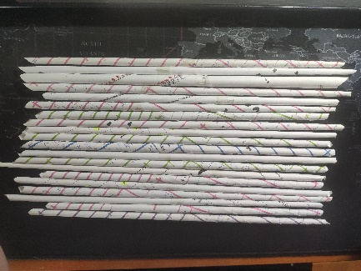
Cut 12 of the bars so they are 15 cm long. The masking tape has to be in the middle, so cut the corners. | 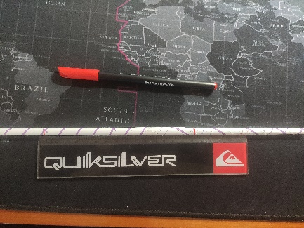  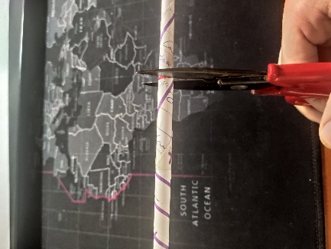  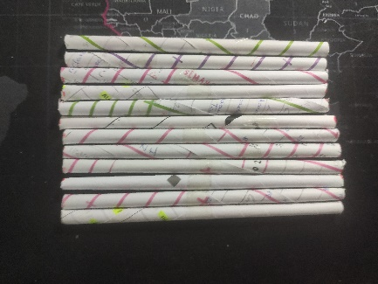
You have to create two squares like the ones in the picture. Join the corners using adhesive tape. | 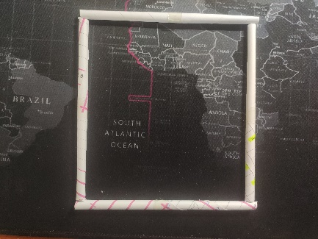  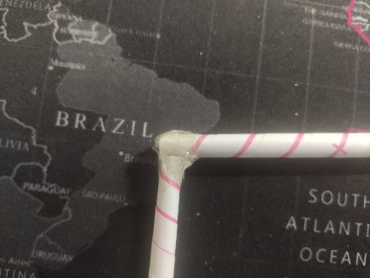  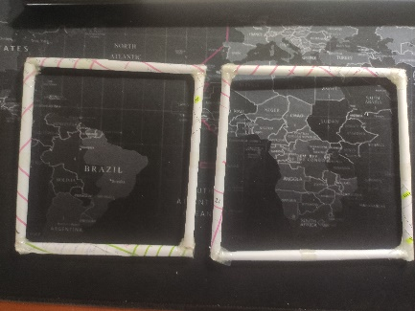
Join the corners of the two squares with the other bars you have cut creating a cube | 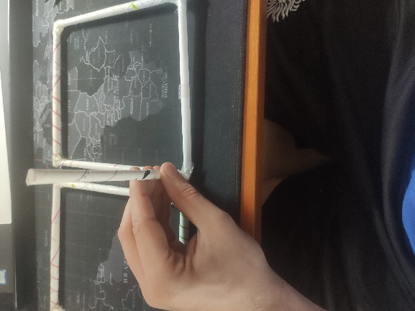  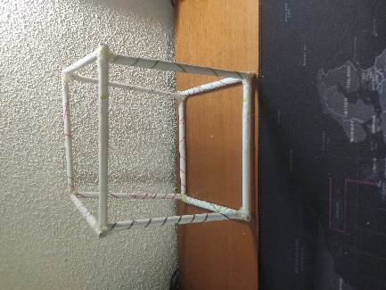
We measure the length that is on the diagonal of the faces of the cube.  We cut the remaining four bars to this length. | 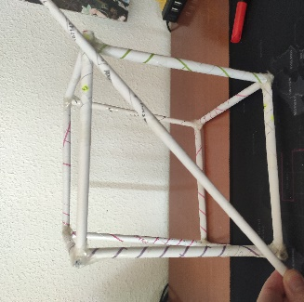
We glue the bars that we have cut on the diagonals of each side face of the cube. These bars are very important because they will give rigidity to our structure. | 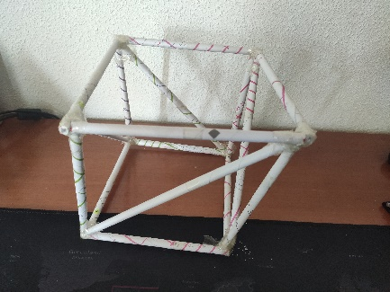
We have already finished our structure. We have to check that it is capable of supporting a load.  For this we will put some books on top and take a photo of it. | 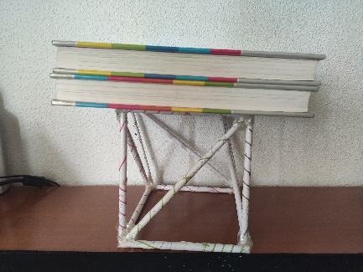
You will have to create your own structure following the steps above. When you have finished it send me a photo of the picture with some books or any weigh on the top.
Here there are three links of some students creating their own structure
https://www.youtube.com/watch?v=VNadrNlOerc
https://www.youtube.com/watch?v=yp-WbY44seM
https://www.youtube.com/watch?v=YPEbYAIobco
To do these exercises you must use four 50-minute sessions, on Thursday the 11th, Friday 12th, Thursday 18th and Friday the 19th of June.
For any doubt, you can contact me at the following email: daniel.nebreda@sanviatorvalladolid.com
¡TAKE CARE!

