Thursday 28th May:
Hello children’s:
The activities to the Activity BooK, you must complete in the activity book.
The grammar you must copy in your note book, take a photo and send me.
And the activities that I send you to review, complete on the computer.
If you can’t hear the audios, tell me and I will send it to your email as an attachment, please.(Si no podéis escuchar los audios por favor decírmelo y os lo mando a vuestro correo como archivo adjunto).
Today we start Unit 8:

Nº 1. Draw and colour the cover to the unit 8 in your note book. Take a photo and send me.
Nº 2. Copy this vocabulary in your note book and translate in Spanish. If you don’t understand some word, ask me. Take a photo and send me.
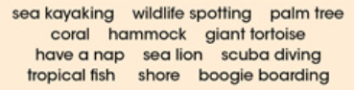
Nº 3
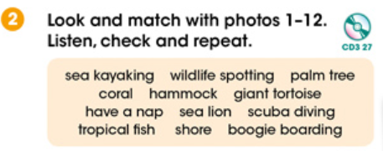
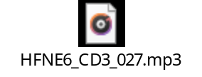
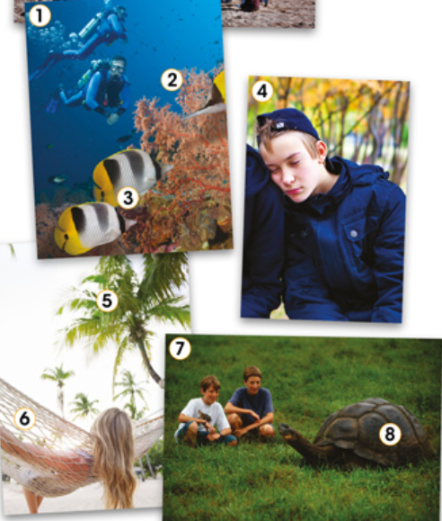
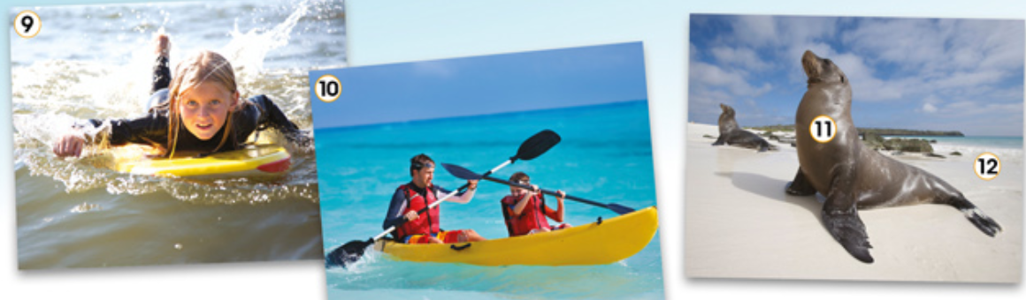

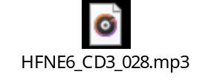
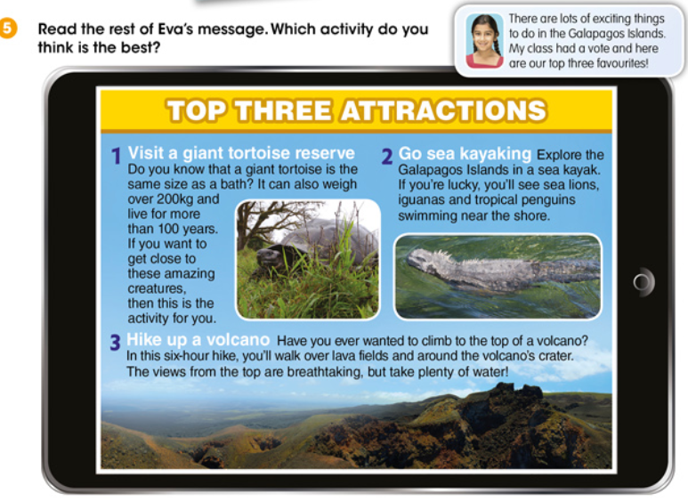

Answers:

Activity BooK:
Page 80: Nº1. Order and write the words.
Page 80: Nº2. Read and complete the definitions. You can help with CD3 Nº 28.
Page 80: Nº3 and Nº 4. Remember the grammar, read and answer the questions.

“Una vez hechas las tareas y los ejercicios y para dudas, puedes contactar conmigo en el siguiente e-mail”:
veronica.tauler@sanviatorvalladolid.com

